Map Results Notes:
Drought Categories by SPI:
https://droughtmonitor.unl.edu/About/AbouttheData/DroughtClassification.aspx
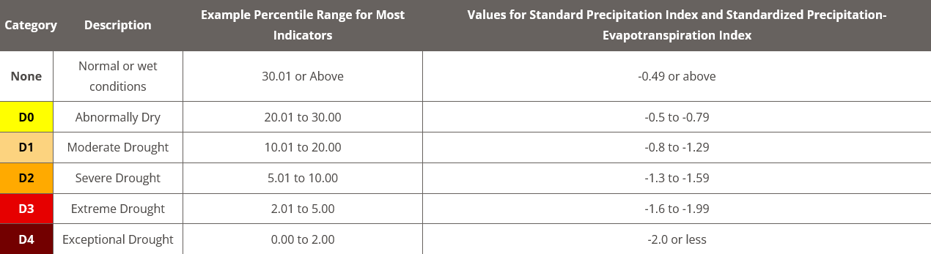

03M:

Frequency:

D0:
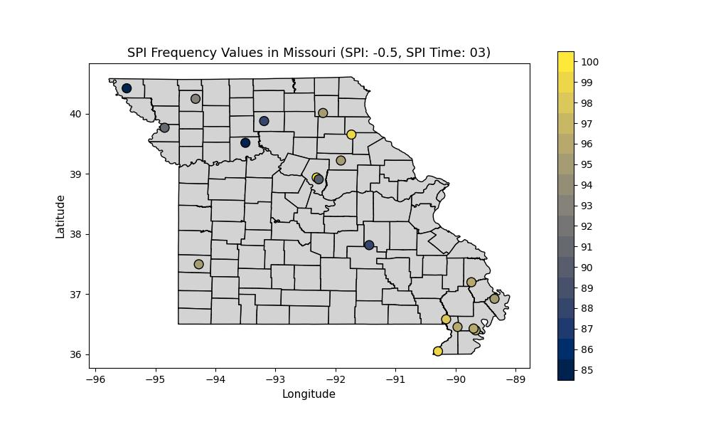
It appears that drought frequency distribution at D0 indicates that the most instances of drought occur in the eastern half of the state, with the cluster of stations in the bootheel indicating that they get drought quite frequently, unlike those to their north and west.

D2:
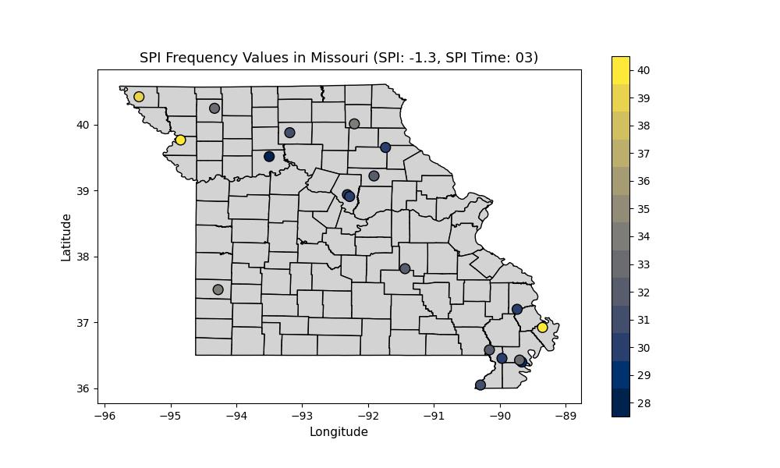
D2 shows a different story. The most frequent locations for D2 drought are in NW Missouri, with only a singular station in the bootheel indicating a high frequency of higher end drought. This means that while drought is most common in the eastern half of the state, it appears that the northwestern half of the state gets the brunt of high-impact drought events.

Duration:

Average Duration:

D0:
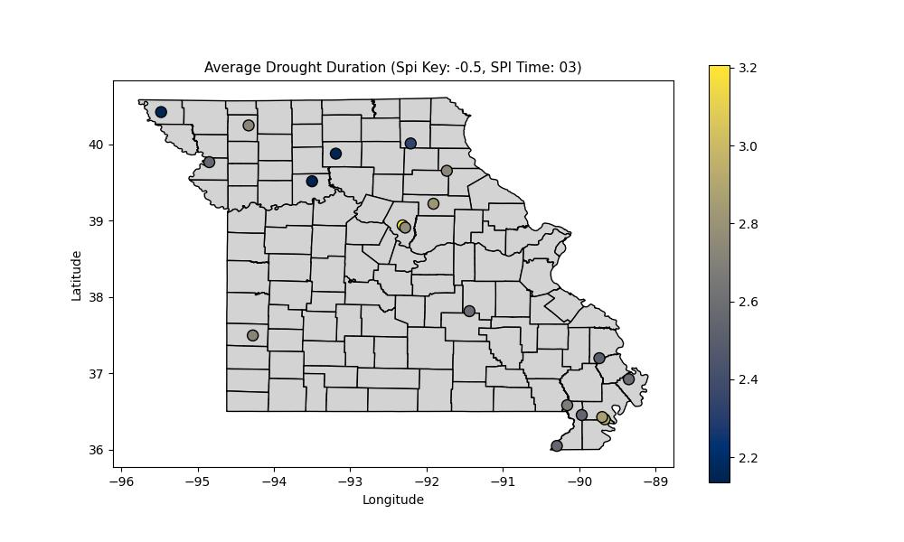
Drought duration shows that Sanborn field’s average duration is by far the longest of the stations around, this could perhaps lend credence to the station having issues with capturing precip, something that has subjectively been brought to my attention in my synoptic meteorology class. If marginal amounts of precip day to day make the difference for crossing the threshold into D0, this could explain why Sanborn stands apart from the rest in this regard. Beyond that, it appears that the SW to NE MO corridor has the longest D0+ droughts, with the bootheel coming in second, and droughts being the shortest in north north-west MO.

D2:
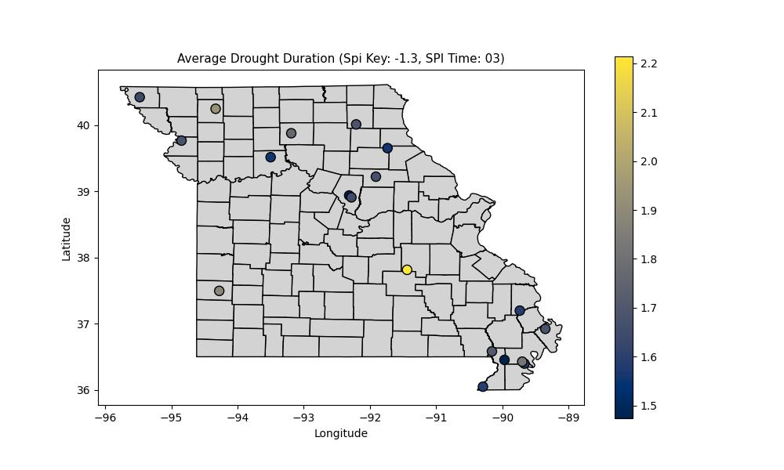
D2 also has an outlier station, the one in Crawford county, which has an average duration of 2.2 months or so for high impact drought. This is a long duration for a drought of this intensity at a 03M time scale. This may need to be investigated further. Regardless, after that we find that drought is lit up a little in the NW portion of the state, with the remainder of the state having minor special variability across stations.

Cumulative Duration:

D0:
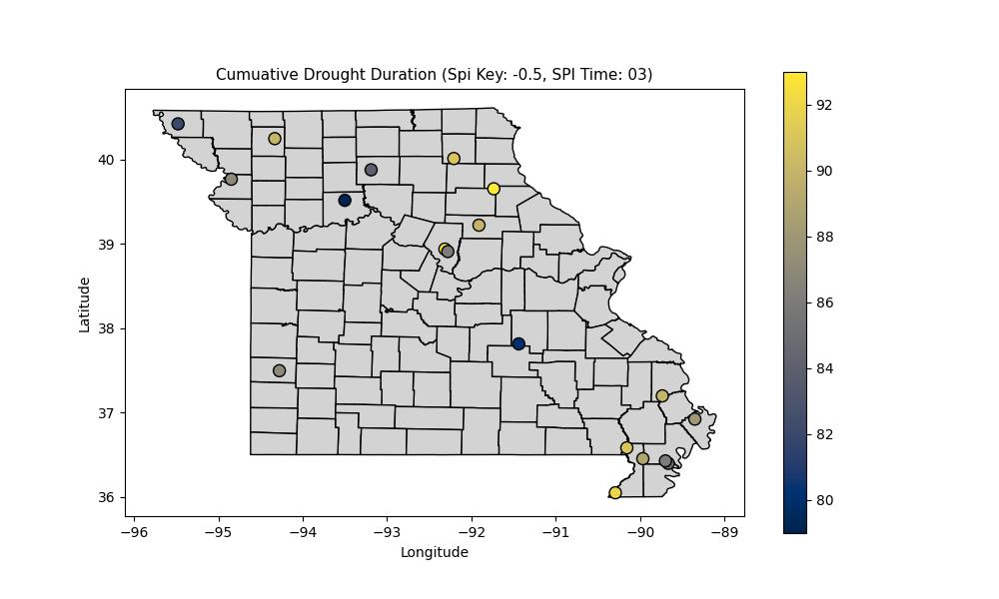
Cumulative duration also tells an interesting story. It appears that the longest cumulative drought duration was in the NE portion of the state, with some continuity. The second region that seems to have a long cumulative duration is the bootheel, though, it does seem a little less extreme overall. The NW portion of the state seems to be the least when it comes to drought duration.

D2:
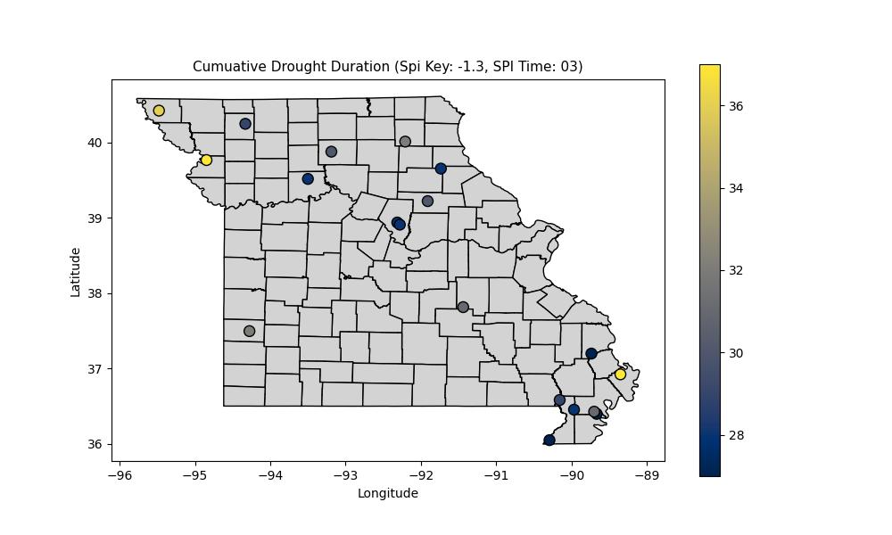
As has started to become a theme at this point. The eastern half of the state is lit-up when it comes to hitting low-impact drought conditions, and the western half of the state is lit up when it comes to high impact drought conditions. This will be investigated further, but it does align well with climatological trends. Curious to see if these trends hold through the 06M and 12M time scales.

Longest Duration:

D0:
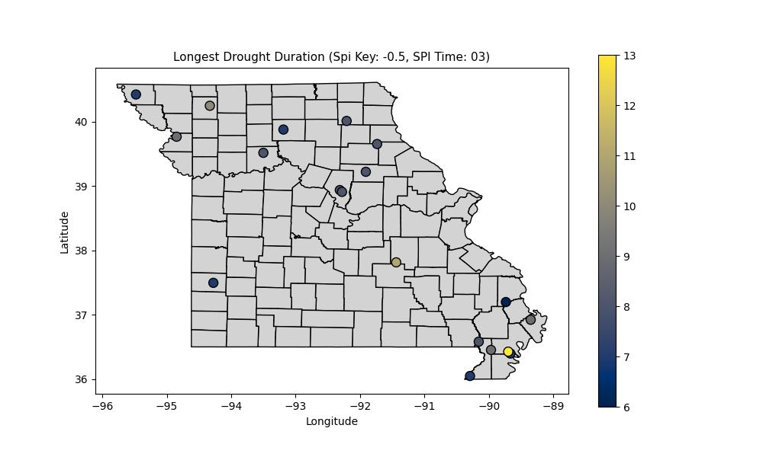
The New Madrid county station takes the cake when it comes to the longest drought duration of anywhere in the state, with their longest D0 lasting just over a year! The strange part of that other stations around it do not share a duration close to this, with all of their droughts lasting for not anywhere near as long. There is also a slightly longer max duration in NW MO than in C-NE MO

D2:
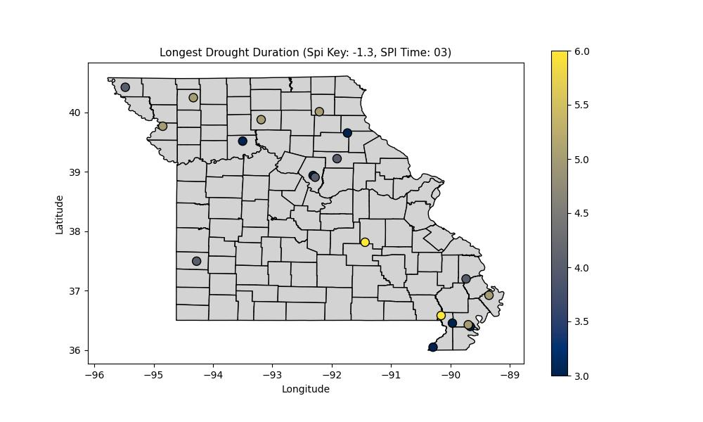
These results surprised me slightly, as they deviated a little from the trend of low impact drought in the east, and high impact drought in the west. It turns out the longest D2+ droughts are also in the east, particularly the southeast. Northern Dunklin county and Crawford county take the cake in terms of duration, both at a tie with 6 months for their maximum D2+ drought duration.

Shortest Duration:
Uniform, every station had a brief one-month drought at some point at both D0 and D2, nothing worth writing about to a detailed degree.

Seasonality:

Onset Seasonality:

D0:
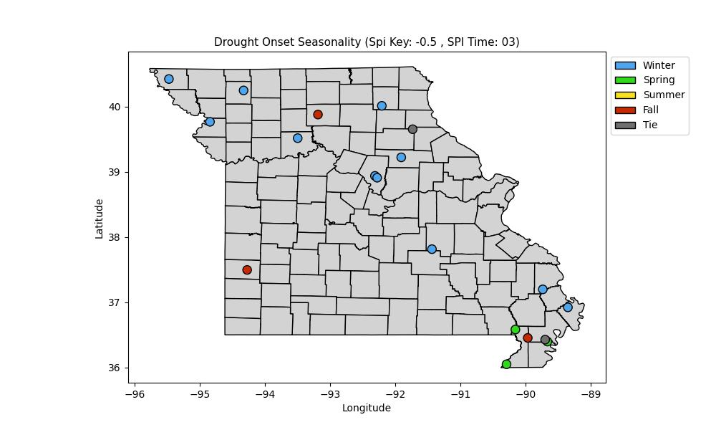
It was interesting to see that of the stations in this study, the vast majority of drought onset occurred in the winter. This could have to do with some seasonality bias and the limitation of these sensors, as I don’t believe (Clarify with Leasor) that these stations are very good with picking up winter precipitation in the form of ice or snow. This could skew the results towards winter, and is a limitation that will need to be directly addressed in this study.

D2:
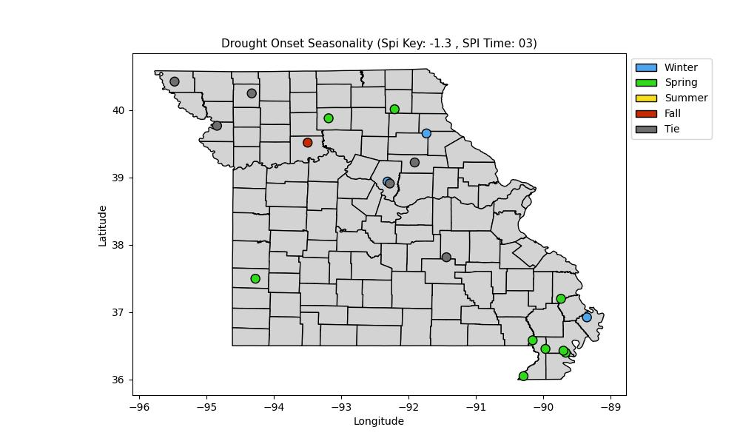
High-impact drought did not have a majority of stations begin in the winter, the majority was either a tie or in the spring, which is interesting to say the least. The bootheel is dominated by spring, with one station at winter, but this could very well be close.

Relief Seasonality:

D0:
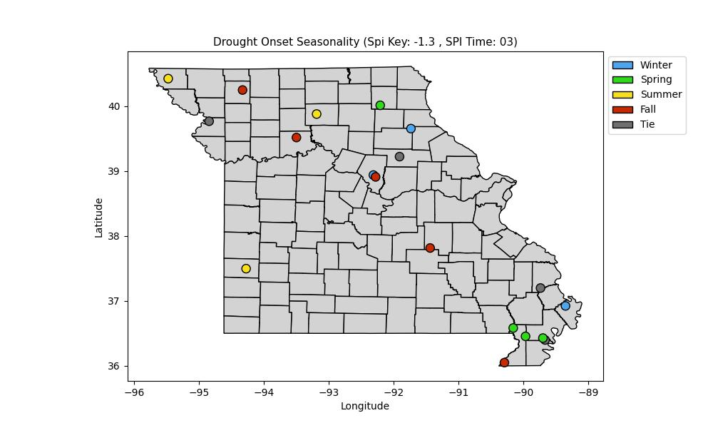
It appears that drought relief is not as clear cut for low-impact drought. In the bootheel transitional seasons tend to be favored, particularly spring. It seems as though summer brings relief in the western half of the state, with fall coming at a second. Beyond that it seems like a bit of a free-for-all in the eastern half of the state, with the notable absence of summer.

D2:
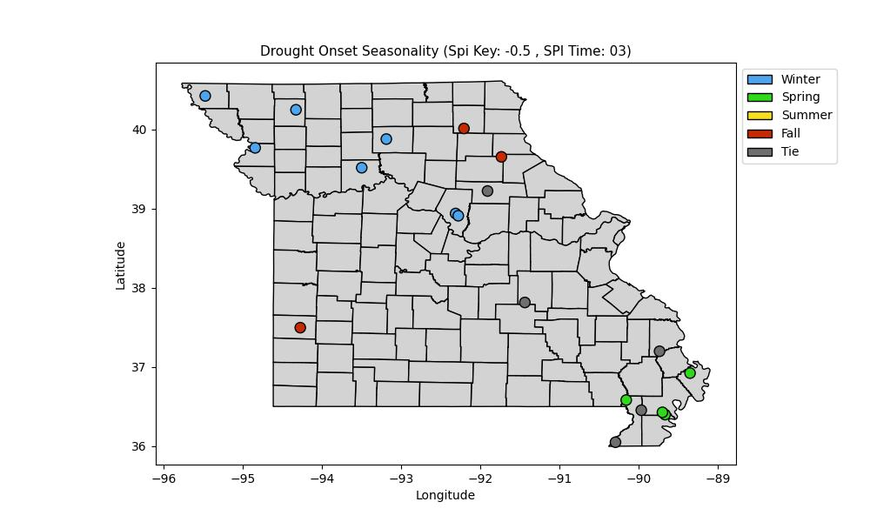
Singnals here are far more clear. There is a universal signal that high-impact drought relief occurs in the Winter for NW MO, and Spring for SE MO. Fall appears most common for the NE and SW, although special resolution and sample size, especially in the southwest limits our findings validity significantly.

06M:

Frequency:

D0:
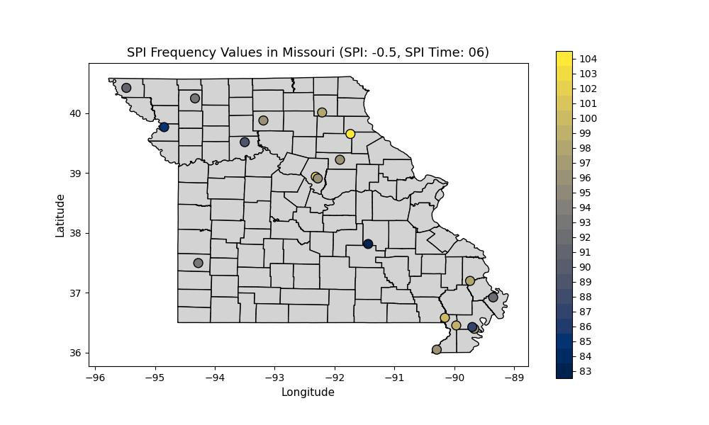
Drought definitely was more frequent in the eastern half of the state than the western half of the state at this time scale, however, Crawford County was a notable outlier in this. Sanborn field once again outclasses South Farm in terms of drought frequency as well. Again, minute precipitation differences between the two stations could account for this.

D2:
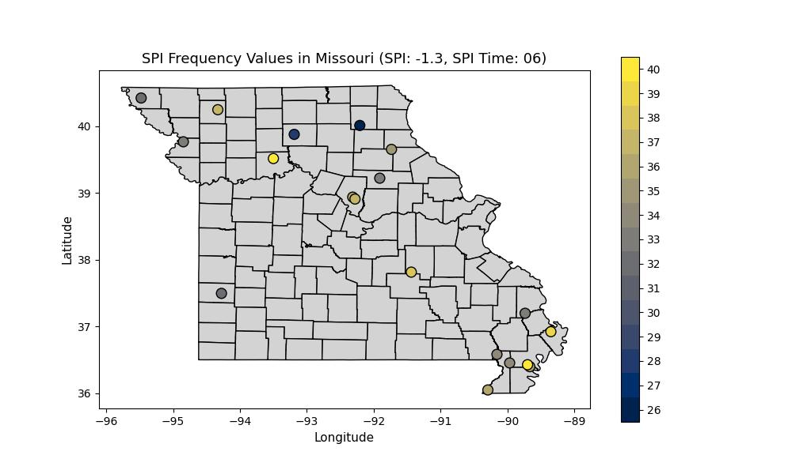
The special distribution of D2 frequency is actually not all that different from D0 at the 06M time scale. It appears that high impact drought is most frequent in the bootheel, with another station in Saline county rivalling that as well.

Duration:

Average Duration:

D0:
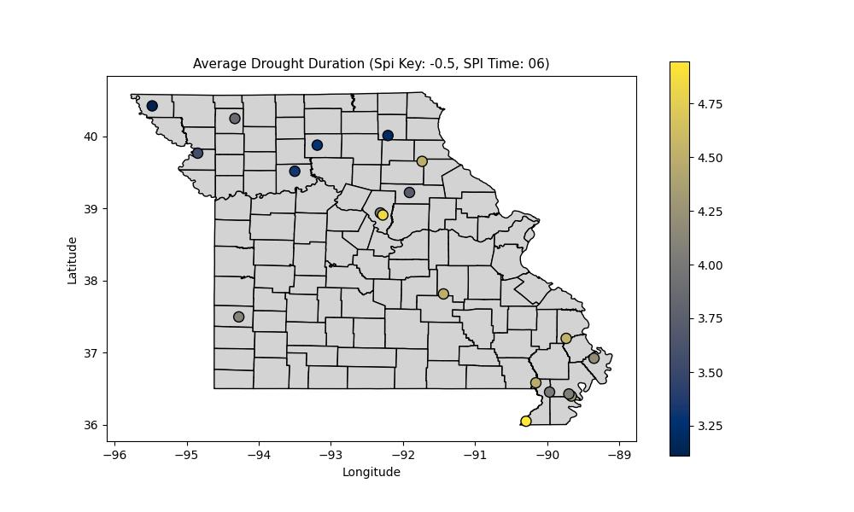
Dunklin and Boone counties take the cake for the longest average drought duration in the state. Once again the boot heel gets lit up a bit, with the NW cluster being less lit up.

D2:
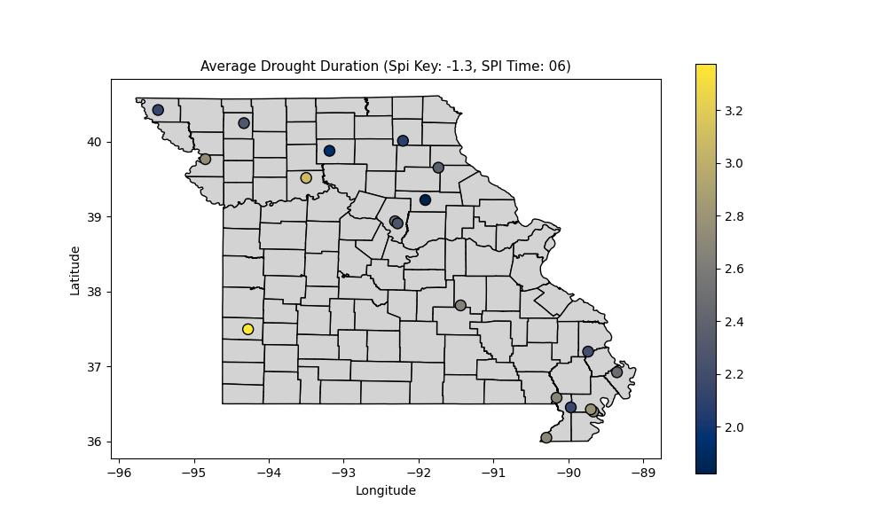
High impact drought has its longest duration in the SW portion of the state. This is of course limited by special resolution as we are only about to use the Barton county station to determine this. Additional investigation maybe needed in the future using additional measurements.

Cumulative Duration:

D0:
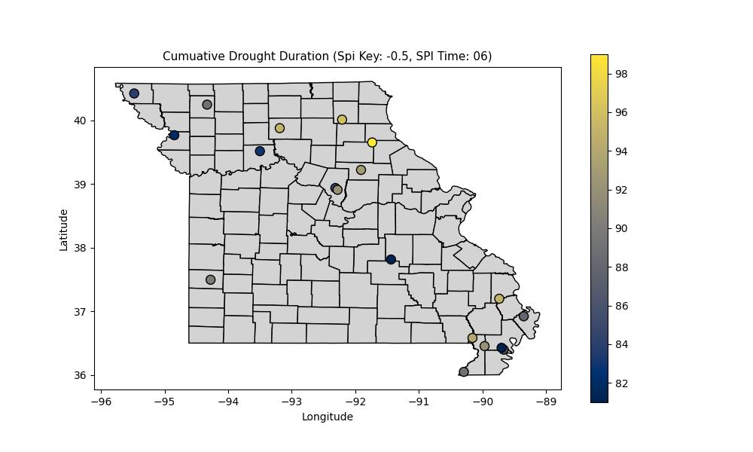
It looks as though the NE portion of the state has had the longest cumulative duration of low-impact drought, with a gradual decline in duration as you move south and west.

D2:
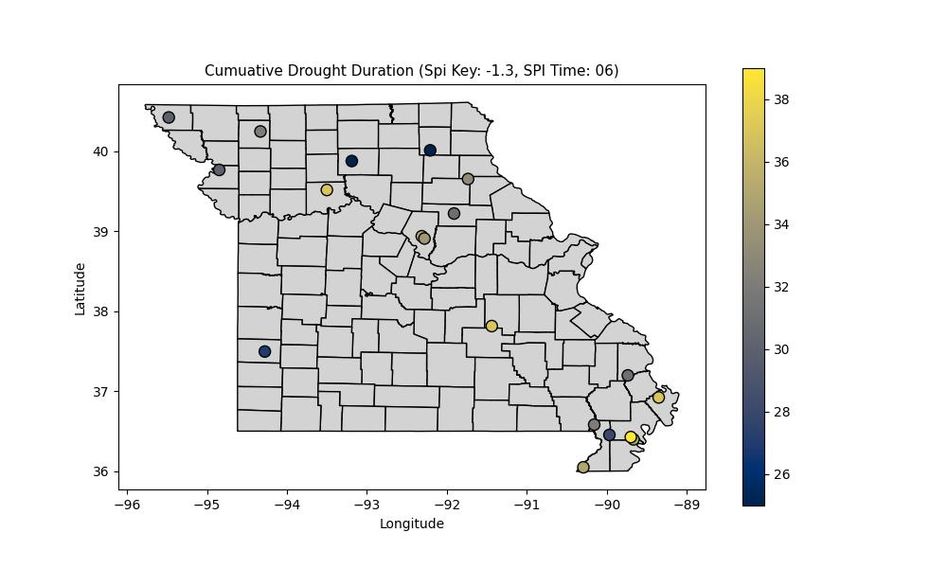
High-impact drought doesn’t have the same spacial continuity. The boot heel looks like the hot spot for high-impact drought, with the remainder fo the state being somewhat similar.

Longest Duration:

D0:
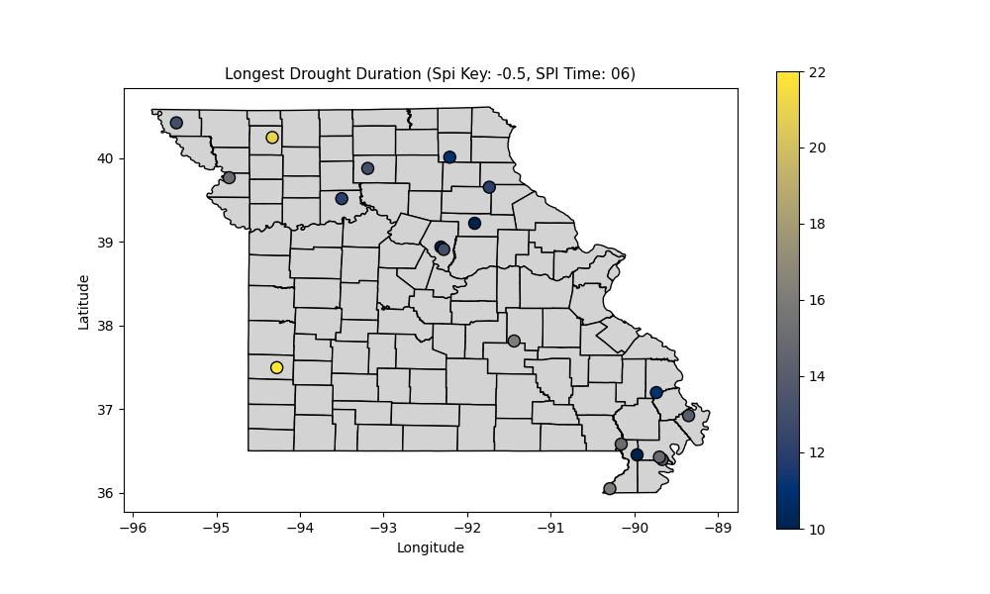
It is notable that the longest drought in Barton county lasted nearly two years! Nowhere else really rivals that except perhaps gentry county. Everywhere else is in the less than a year to maybe a year and a half range for their longest ever drought.

D2:
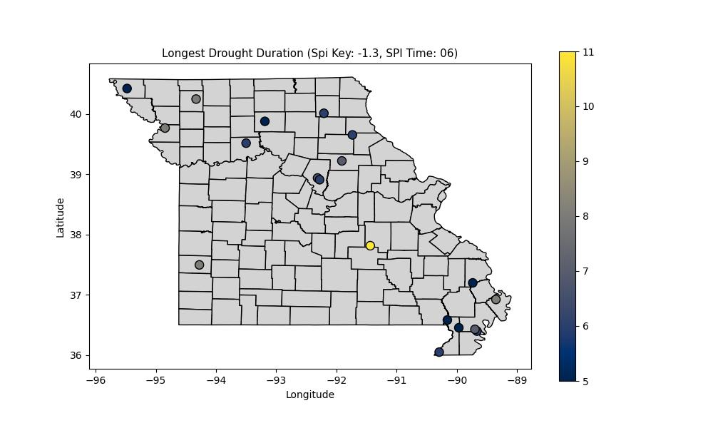
High-impact drought is even more interesting. Spacial variability across the state is minimal in terms of maximum high-impact drought duration, at about half the year for every station but one. The Crawford county station had a high-impact drought that lasted for 11 consecutive months.

Shortest Duration:
Uniform, every station had a brief one-month drought at some point at both D0 and D2, nothing worth writing about to a detailed degree.

Seasonality:

Onset Seasonality:

D0:
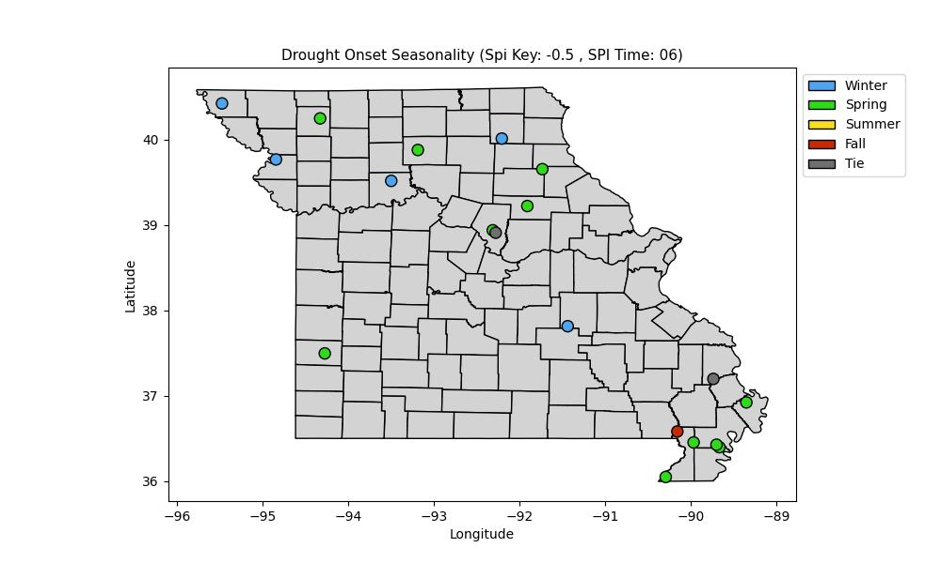
It looks like winter and spring dominate the drought onset seasonality, with spring taking the cake in the SE and the winter taking the cake in the NW

D2:
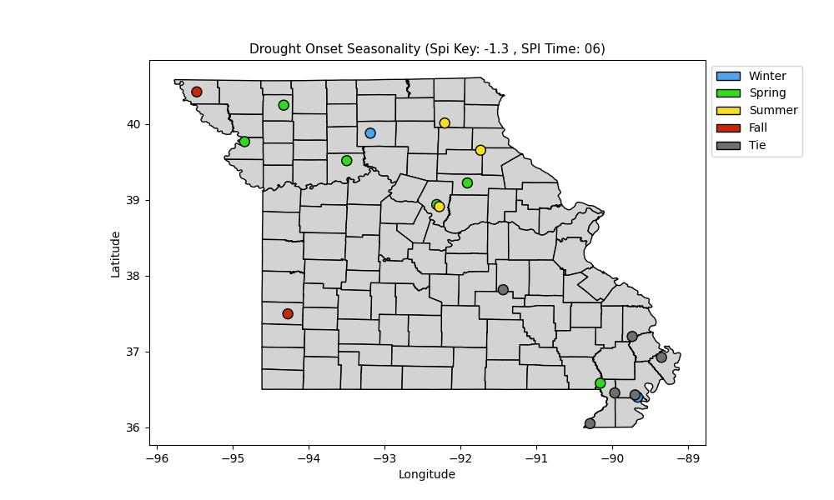
High-impact drought onset looks to have a variety of seasons where it can begin. In C-MO, it looks like spring-summer is most common, this remains the same in NE MO. The boot heel has a tie for many of the stations, with the spring looking to be most frequent in the NW portion of the state, with a couple stations reporting fall for their most frequent high-impact drought onset season on the western side of the state.

Relief Seasonality:

D0:
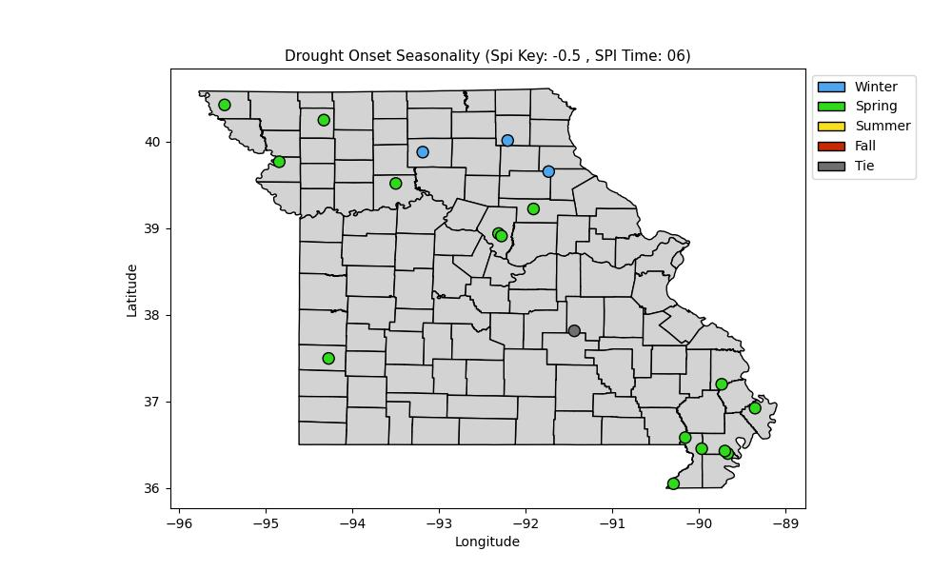
Drought relief is overwhelmingly in the spring, with the only part of the state that tilts towards winter being the NE part of the state

D2:
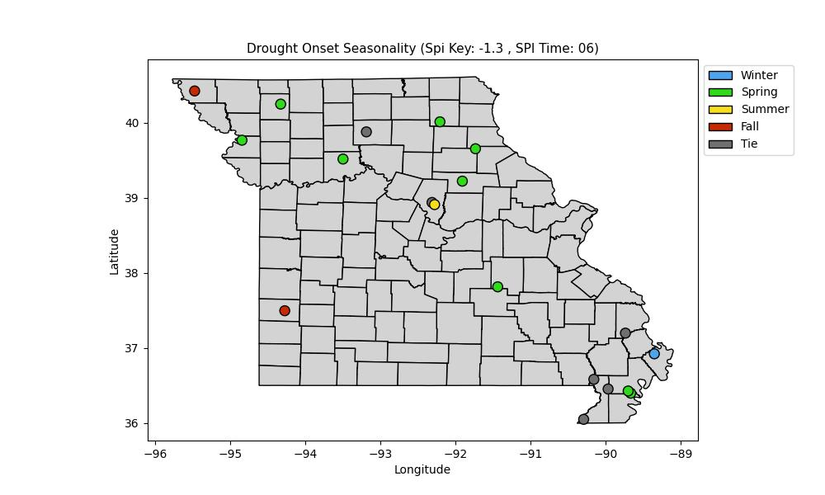
High-impact drought relief is a slightly different story. Spring is still most frequent for it across the state, but there are some differences. W MO has fall return as a contender, and C-MO has relief in the summer, Urban heat island CI? The Mississippi county station most frequently has drought relief in the winter.

12M:

Frequency:

D0:
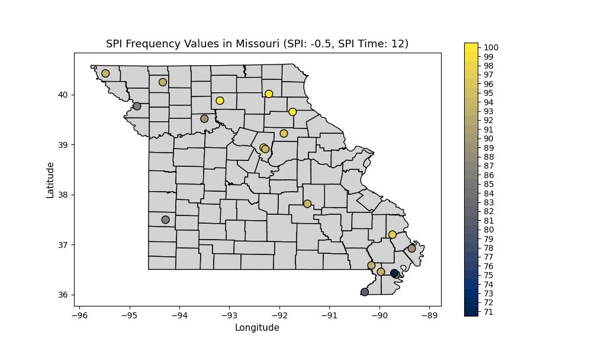
The most notable thing to start with this is that there is more spread in terms of frequency across the state at 12M relative to any of the others, with anywhere from 71-100 months being low-impact drought months across the state. This means that anywhere from 6-9 years or so, depending on where you are. That’s a large amount of variability. The north, and especially northeastern side of MO have seen around 9 years of drought, while areas in the bootheel have seen over two years less over a 24 year period! That’s substantially less!

D2:
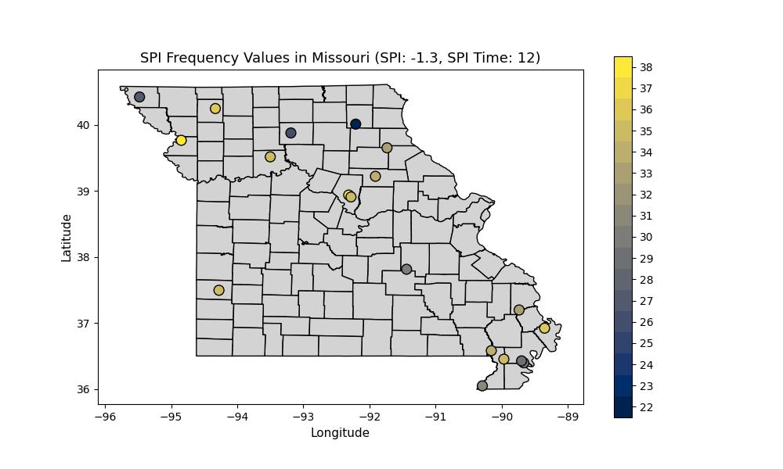
When it comes to high impact drought there is a reversal in terms of spacial distribution to some degree. The NE portion of the state is now on the lower end of months in a high-impact drought, while the NW portion of the state in particular is more lit up in this regard.

Duration:

Average Duration:

D0:
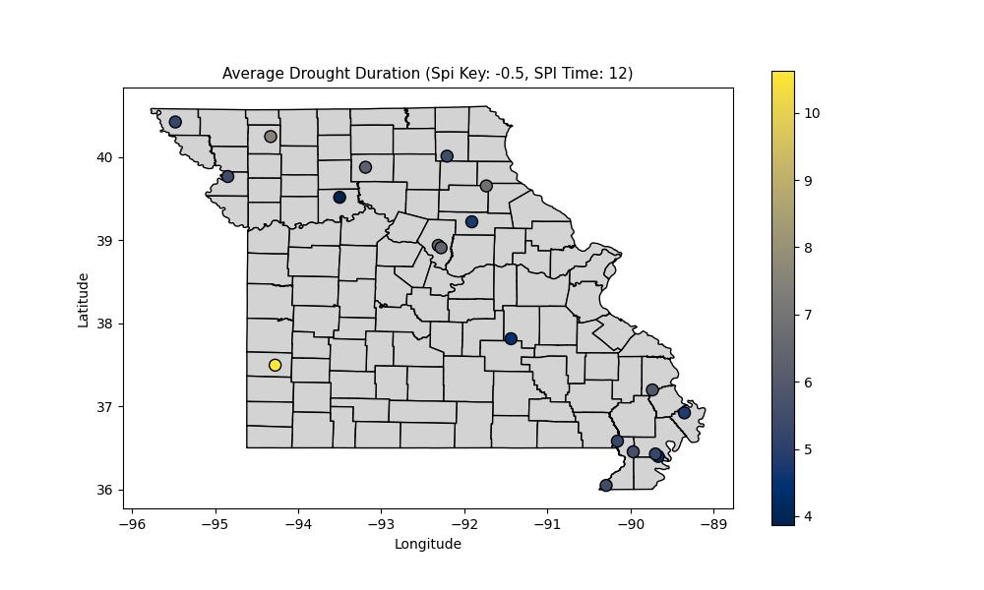
Average drought duration was fairly uniform across the state with the notable exception of Barton county. That station had an average duration of over 10 months! That’s crazy!

D2:

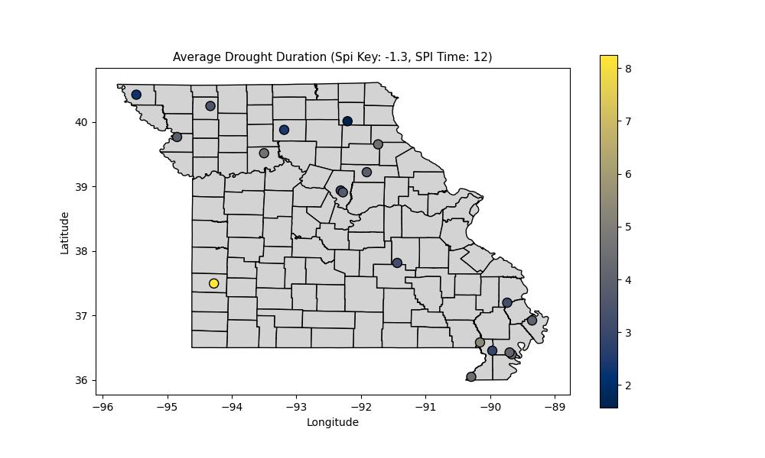
The same general result is present for D2+ drought, except now it’s an average duration of just over 8 months instead of 10. Still crazy though!

Cumulative Duration:

D0:
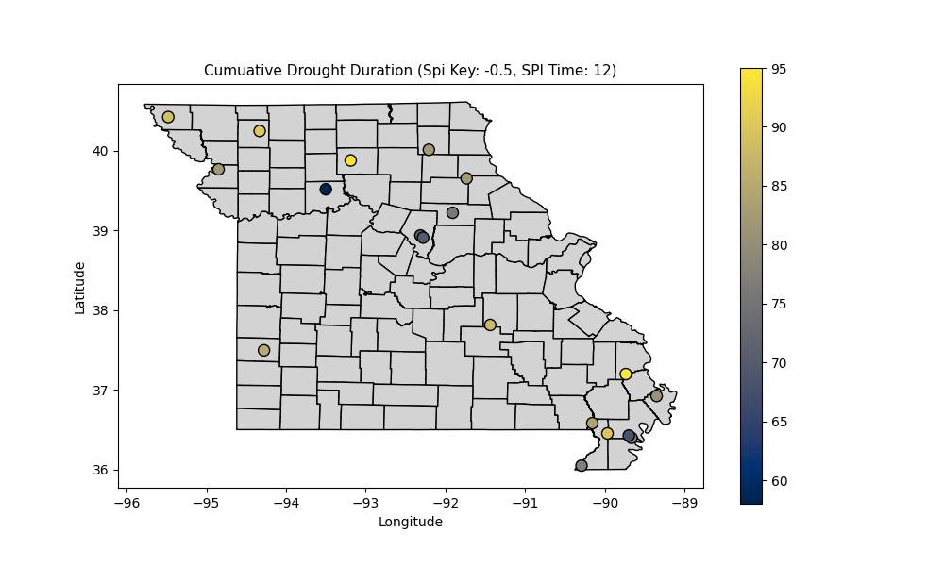
Cumulative drought duration tells a different story, suddenly Barton county fits right in, which leads to a suggestion that there was one particularly long event that has significantly bumped up the average down there. It seems drought has been present the longest in the bootheel and the NW side of the state.

D2:
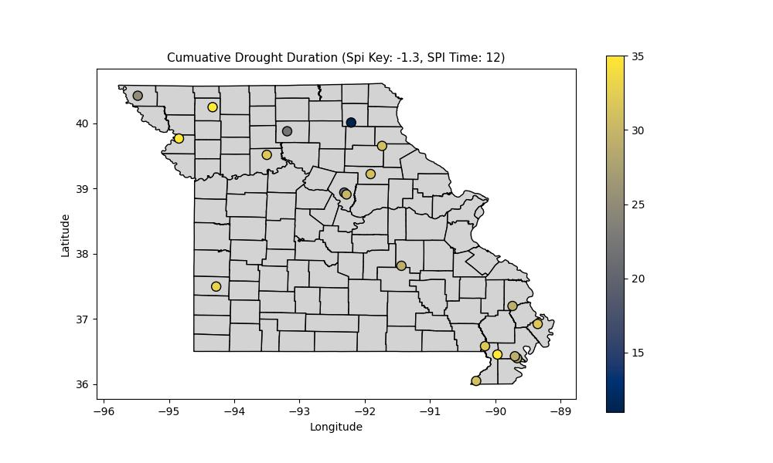
Same story with high-impact drought, although much of the state has had at least 20 months of D2+, there is one station in Knox county that has had around a year of D2+, which is substantially lower than the rest of the state

Longest Duration:

D0:

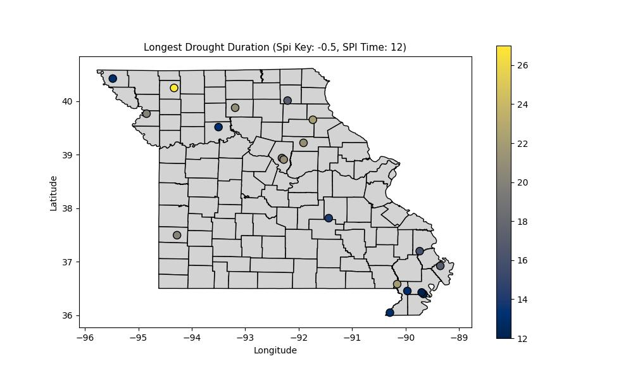
The longest low-impact drought lasted OVER TWO YEARS in Gentry county! Other areas longest droughts lasted at least a year, with a few stations flirting with a year and a half.

D2:

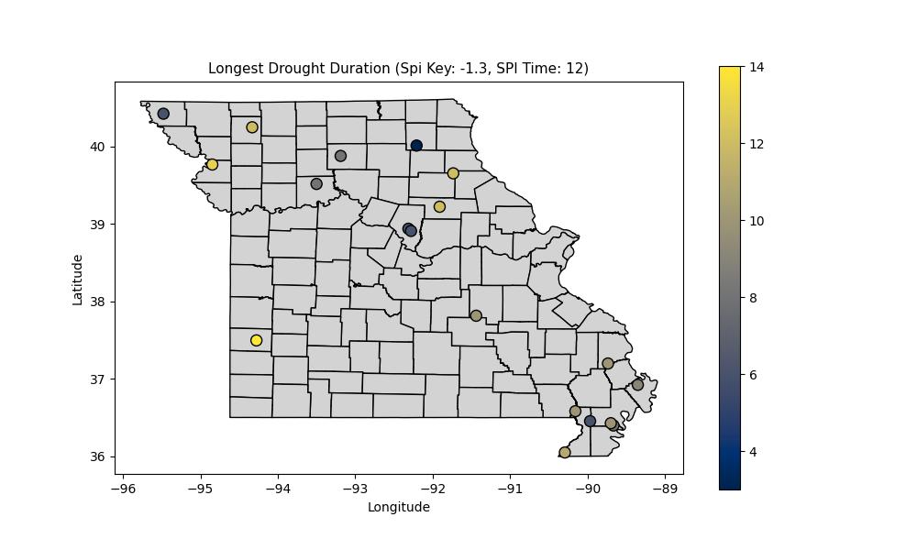
D2 and Barton county is lit up again as having by far the longest D2+ stretch at over a year! The NW side of the state also had D2+ conditions for a while, with the remainder of the state looking more uniform.

Shortest Duration:
Uniform, every station had a brief one-month drought at some point at both D0 and D2, nothing worth writing about to a detailed degree.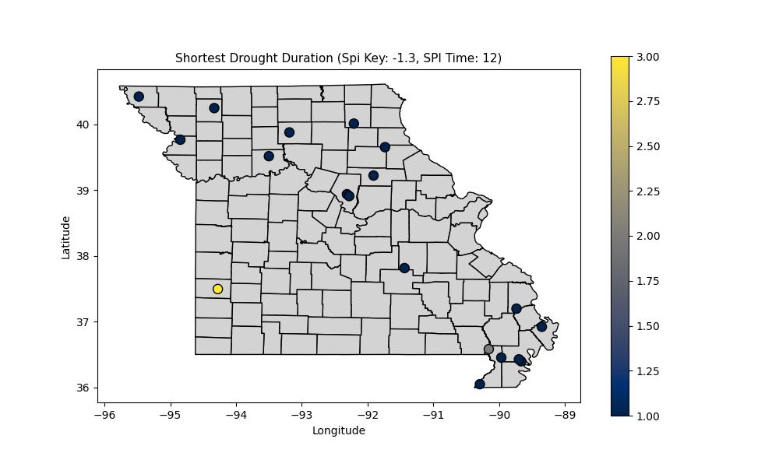
Only thing of note is that the shortest D2 duration in Barton County is 3 months!

Seasonality:

Onset Seasonality:

D0:

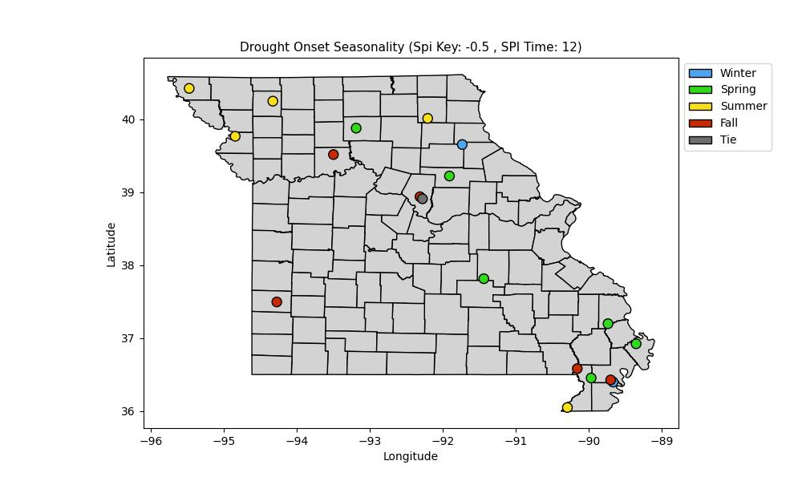
We have a variety of different seasons for drought Onset Seasonality. The major thing of note here is that there is spacial continuity in a few trends. I am also keeping a close eye on the Barton County station since it has been an outlier in a big way. The NW portion of MO seems to favor summer for drought onset, while the bootheal and C-MO favor the transitional seasons. Barton county favors fall for low-impact drought onset.

D2:

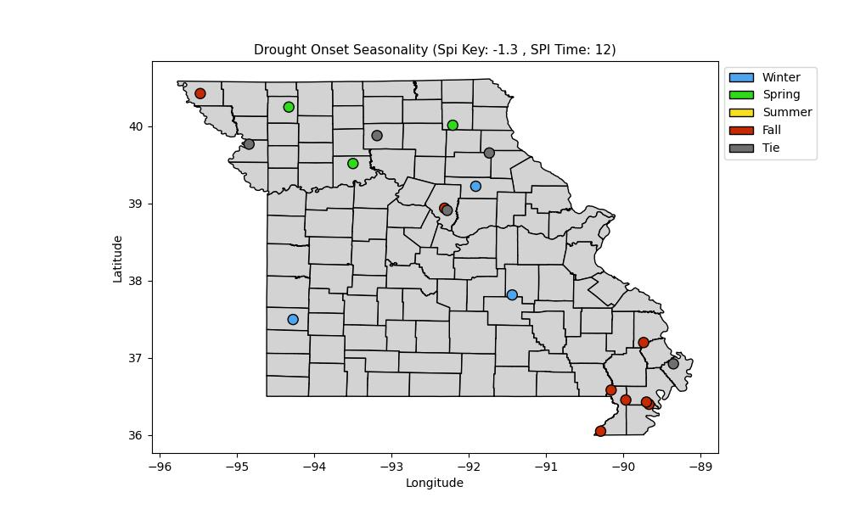
With high impact drought winter is when Barton county sees onset, with fall being the universal season for high-impact drought onset in the boot heel.

Relief Seasonality:

D0:
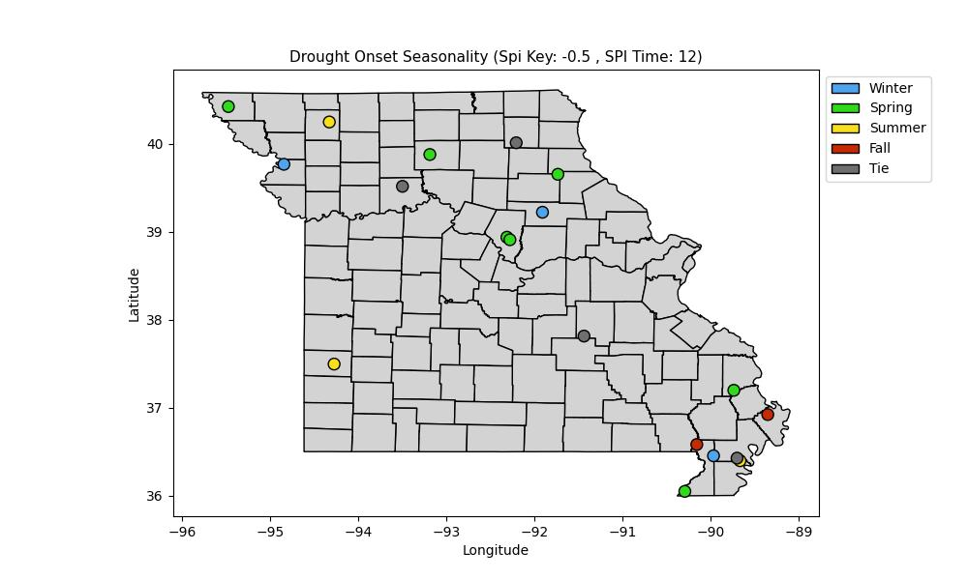
Drought relief seems a bit more ambiguous, with winter and spring being most common, but all four seasons seem to have their fair share, even within the same portions of the state! The bootheel has stations with all four seasons! It also has a station with a tie.

D2:
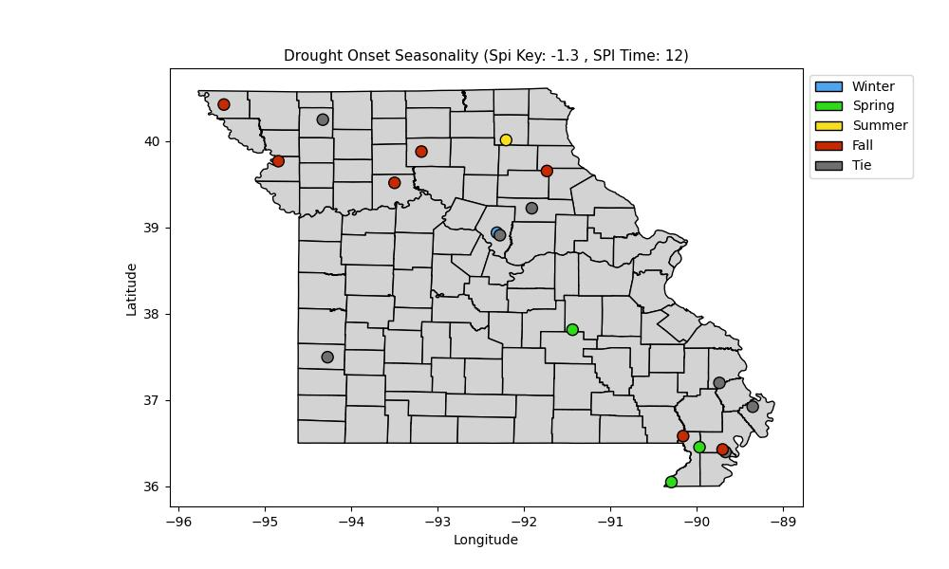
High-impact drought relief is a little more concrete. It looks like NW MO sees relief most frequently in the fall, while the bootheel sees it most in transitional seasons.

